Band Camp Donations Needed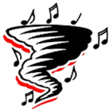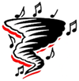
Water, water, water- gallons
  - Powdered Gatorade- big 5-6 gallon size
  - Paper Towels
  - Safety pins, bandages of ALL sizes, small hair bands
  - Ice packs- the kind you break to get cold
  - Individual nail polish remover wipes
  - Windex disposable wipes
  - Peanut Butter, Jelly and bread
  - Good Fabric Scissors to cut glove tips
  - Individually packed crackers, cookies, pop-tarts, etc.
  - Tents, coolers
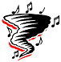Donations can be dropped off during band camp or in the band uniform room. 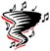
Please contact: chstornadosband@gmail.com for more information or to ask questions.

